**ORM Cerner to TeleTracking Requirements**

**Version 1.3**

**Prepared By: Rich Allison**

**Date: 5/14/19**

Document Control 3

Resources 3

Project Distribution List 3

Document Version Control 3

1. Introduction 4

1.1 Purpose 4

1.2 Project Scope 4

1.3 Terminology Standards 4

1.3.1 Acronyms 4

1.3.2 Glossary 4

1.4 Document References 5

2. Diagram 5

3. Requirements 5

3.1 Functional Requirements 5

3.2 Non-Functional Requirements 5

3.3 Messaging Protocols 6

3.3.1 Inbound to the BayCare Cloverleaf 6

3.3.4 Outbound to the TeleTracking 6

4. HL7 Messaging 6

4.1 Messaging Format 6

4.1.1 Segments 6

4.1*.*2 Messaging Event Types 7

4.1*.*3 Cloverleaf Configuration Files 7

4.1.4 Cloverleaf Site Location 7

4.2 Data Transformation Requirements 8

4.3 Sample Message 13

5. Testing 22

5.1. Unit Testing Scenarios 22

5.2 Integrated Testing Scenarios 22

5.3 Testing Approvals 22

5.4 Piloting 23

5.5 Approvals 23

6. Deployment / Implementation Model 23

6.1 Alerts 23

Appendix A: Risks and Concerns 24

Appendix B: Issues List 24

# **Document Control**

## Resources

|  |  |  |
| --- | --- | --- |
| **Name** | **Role** | **Email** |
| Stephen Mattei | Enterprise Integration Analyst, Sr. | Stephen.mattei@baycare.org |
|  |  |  |
|  |  |  |
|  |  |  |
|  |  |  |
|  |  |  |

## Project Distribution List

## Document Version Control

|  |  |  |  |
| --- | --- | --- | --- |
| **Version** | **Date** | **Modifier** | **Description** |
| V1.0 | 9/26/17 | Rich Allison | Originally Created |
| V1.1 | 10/03/18 | Sailaja Parimi | Added logic for OBR-4 to send out order aliases |
| V1.2 | 07/26/2019 | Tom Fredrickson | Added Cerner Model changes. |
|  |  |  |  |
| V1.3 | 05/14/19 | Charles CJ Markwardt | Changing suppression logic on the FSI side. See the Functional Requirements section for model changes. |
|  |  |  |  |
|  |  |  |  |
|  |  |  |  |
|  |  |  |  |
|  |  |  |  |

# 1. Introduction

## 1.1 Purpose

The Purpose of this document is to outline the Orders interface requirements from Cerner for the Enterprise TeleTracking application. Coding uses inclusive Facility Nomenclature (not Nurse Stations – i.e. SJH, MPH, etc.).

## 1.2 Project Scope

Integration for this application includes an ADT interface from Soarian and an Orders interface from Cerner. The scope of this project was to roll out a standard version of this application to all BayCare Facilities.

## 1.3 Terminology Standards

### 1.3.1 Acronyms

**ORM** – Order Message

### 1.3.2 Glossary

**TeleTracking** is the vendor name.

**Capacity Management Suite** is the system comprised of Patient Tracking Portal, PreAdmitTracking with electronic bedboard, TransportTracking and BedTracking.

**Orders include:**

|  |  |
| --- | --- |
| Order Alias to Teletracking | Cerner Order Description |
| Admit To | Admit to Inpatient |
| Admit To | Place in Observation |
| Admit To | ED Admit Bed Request |
| Admit To | ED Transfer to Special Area |
| ADMIT BED INFO | Admit Additional Bed Info |
| Discharge Patient | Discharge Patient |
| Isolation | Isolation |
| ADOD | Anticipated Date of Discharge |

## 1.4 Document References

HL7 Interface Software Specifications Guide for the Capacity Management Suite

TeleTracking Interfaces

# 2. Diagram

Provide a solution diagram that depicts the integration of components specified in this IDBB. This diagram must include the data flow for the interfaces (source and target).

# 3. Requirements

## 3.1 Functional Requirements

Provide detail for the below functional requirements. The message transformation requirements for the components defined in this specification should be specified in section 4.2 of this document.

|  |  |  |
| --- | --- | --- |
| **Cloverleaf** |  |  |
| **Number** | **Requirement Name** | **Requirement Description** |
| FR.20XX.1.0 | Click here to enter text. | Click here to enter text. |

|  |  |  |
| --- | --- | --- |
| **FSI** |  |  |
| **Number** | **Requirement Name** | **Requirement Description** |
| FR.2019.5.14 | Order selection logic | Orders will only make it out from the Cerner side if the activity sub type CDF meaning = “BEDCTRL” and the Activity type is in ("ADMITTO", "BAYESOSUPRES", "COMMUNICATIO") |
|  | Contributor system Invision | Invision is Cerner’s main contributor system. This system is used across multiple interface throught the orginzation. So when alais are added to the contributor source it will impact more than just this interface.  **Contributor Source:** Invision  **Organization:** Baycare Heatlh Systems  **Message Format:** HL7 V2.x  **Outbound Field Processing**  MSH.3 Sending Application = HNAM  MSH.4 Sending Facility = CERNER  MSH.5 Receiving Application = INVISION  MSH.6 Receiving Facility = BAYCARE  **Outbound aliasing**  OBX.3 Observation ID comes from the the contributor source LOINC |

## 3.2 Non-Functional Requirements

Provide concise detail for the below non-functional requirements. The below requirements must be evaluated for every project.

|  |  |  |
| --- | --- | --- |
| **Cloverleaf** |  |  |
| **Number** | **Requirement Name** | **Requirement Description** |
| NFR.20XX.1.0 | Click here to enter text. | Click here to enter text. |

## 3.3 Messaging Protocols

Below are listed the details for the messaging protocols that will be leveraged for this integration. Please see the reference document located on the Integration SharePoint server: <insert link to document here>

### 3.3.1 Inbound to the BayCare Cloverleaf

* TCP MLLP Server Connection

### 3.3.2 Outbound from Cerner FSI to Cloverleaf

* TCP MLLP Server Connection

### 3.3.4 Outbound to the TeleTracking

* TCP MLLP Server Connection

# 

# 4. HL7 Messaging

## 4.1 Messaging Format

### 4.1.1 Segments

The segments utilized for this interface are:

MSH

PID

PV1

PV2

ORC

OBR

NTE

OBX

*Message Construction Notes:*

*[Square Brackets] – Optional*

*{Curly Brackets} – Repeatable*

*MSH – Message Header*

*EVN – Event segment*

*PID – Patient ID segment*

*PV1 – Patient Visit segment*

*PV2 – Patient Visit Additional Information segment*

*ORC – Common Order segment*

*OBR – Observation Request segment*

*NTE – Notes and Comments*

*OBX – Observation / Result Segment*

### 4.1*.*2 Messaging Event Types

Below are the messages types necessary for this integration

|  |  |
| --- | --- |
| **Event Type** | **Description** |
| ORM_O01 | Transport Order Message |

### 4.1*.*3 Cloverleaf Configuration Files

For each HL7 interface specified in Section 2 of this document, identify the Cloverleaf Configuration Files: Variants, TCL Scripts, Xlates, etc.

Variants:

HL7 2.3/cerner_emr ORM_O01

TCL Scripts **Inbound Data Procs**:

tpsCernerCommonCode

change_to_less_than

TCL Scripts **Pre Procs**:

tpsHL7ChangeData2

Blanks out the following fields:

PID-5.7 Patient Name – Name Type Code

PID-18.4 Patient Account Number – Assigning Authority

PID-18.5 Patient Account Number – Identifier Type Code

TCL Scripts **Post Procs**:

tpsAdvHL7Filter:

If MSH:12 Version ID = S Kill the message.

Xlates:

cerner_teletrac_orm.xlt

Tables:

cer_tele_si.tbl

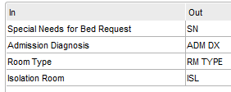

### 4.1.4 Cloverleaf Site Location

teletrck_24_p

## 4.2.1 FSI Data Transformation Requirements

| **Field Description** | **HL7 Field Loc.** | | **Required Y/N** | | **Data Type** | | **Length** | | **Notes** | |
| --- | --- | --- | --- | --- | --- | --- | --- | --- | --- | --- |
| Message Segment Header | | MSH | | Y | | Varies | | Varies | | Pathcopy the entire segment. | |
| Sending Application | | MSH.3 | | Y | |  | |  | | HNAM | |
| Sending Facility | | MSH.4 | | Y | | HD | | 227 | | CERNER | |
| Receiving Application | | MSH.5 | |  | |  | |  | | INVISION | |
| Receiving Facility | | MSH.6 | | Y | |  | |  | | BAYCARE | |

## 4.2.2 Cloverleaf Data Transformation Requirements

| **Field Description** | **HL7 Field Loc.** | **Required Y/N** | **Data Type** | **Length** | **Notes** |
| --- | --- | --- | --- | --- | --- |
| MSH Segment |  | Y |  |  |  |
| Sending Application | MSH.3 |  |  |  | COPY “HNAM” |
| Sending Facility | MSH.4 |  |  |  | COPY “BAYCARE” |
| Receiving Application | MSH.5 |  |  |  | COPY MSH.5 to @fac  COPY @fac to MSH.5 |
| Receiving Facility | MSH.6 |  |  |  | COPY @fac to MSH.6 |
| Date/Time of Message | MSH.7 |  |  |  | YYYYMMDDHHMMSS |
| Message Type | MSH.9 |  |  |  | Trigger Event (ADT^A01) |
| Processing ID | MSH.11 |  |  |  | Defaulted to “P” |
| Sequence Number | MSH.13 |  |  |  |  |
| PID Segment |  | Y |  |  |  |
| Patient ID | PID.3 |  |  |  | COPY PID.2.0 to PID.3 |
| Patient Name | PID.5 |  |  |  | PATHCOPY Patient Name |
| Birth Date | PID.7 |  |  |  | COPY PID.7 |
| Sex | PID.8 |  |  |  | COPY PID.8 |
| Patient Address | PID.11 |  |  |  | COPY PID.11 |
| Phone Number - Home | PID.13 |  |  |  | COPY PID.13 |
| Phone Number - Business | PID.14 |  |  |  | COPY PID.14 |
| Patient Account Number | PID.18 |  |  |  | COPY PID.18 |
| PV1 Segment |  | Y |  |  |  |
| Patient Class | PV1.2 |  |  |  | Patient Class: (Coding uses inclusive Patient Class I or E):   * I for Isolation & Discharge Pt Orders * E for Admit to, ADOD, and Admit Bed Info Orders |
| Assigned Patient Location | PV1.3 |  |  |  | PATHCOPY NS^Room^Bed^Facility  COPY @null to PV1.3.6 |
| Admission Type | PV1.4 |  |  |  | Circumstance under which the patient was admitted…  COPY PV1.4 |
| Attending Doctor | PV1.7 |  |  |  | ITERATE:  IF PV1.7.8 eq @fac  xlt_PadLeft =0 =5  COPY PV1.7.0 to PV1.7.0  Concatenate the facility in front of doctor number…  CONCAT @fac to PV1.7.0  COPY PV1.7.1 to PV1.7.1  COPY PV1.7.2 to PV1.7.2  COPY PV1.7.3 to PV1.7.3  COPY PV1.7.4 to PV1.7.4  COPY PV1.7.5 to PV1.7.5  COPY PV1.7.6 to PV1.7.6 |
| Hospital Service | PV1.10 |  |  |  | COPY PID.10 |
| Admit Source | PV1.14 |  |  |  | COPY PV1.14 |
| Admitting Doctor | PV1.17 |  |  |  | ITERATE:  IF PV1.17.8 eq @fac  xlt_PadLeft =0 =5  COPY PV1.17.0 to PV1.17.0  Concatenate the facility in front of doctor number…  CONCAT @fac to PV1.17.0  COPY PV1.17.1 to PV1.17.1  COPY PV1.17.2 to PV1.17.2  COPY PV1.17.3 to PV1.17.3  COPY PV1.17.4 to PV1.17.4  COPY PV1.17.5 to PV1.17.5  COPY PV1.17.6 to PV1.17.6 |
| Servicing Facility | PV1.39 |  |  |  | COPY @fac PV1.39 |
| Expected Discharge Date | PV2.9 |  |  |  | COPY PV2.9 to PV2.9 |
| ORC Segment |  | Y |  |  |  |
| Order Control | ORC.1 |  |  |  | COPY ORC.1 to ORC.1  Make the “SN” a “NW” for new orders from Cerner…  IF ORC.1 eq “SN”  COPY “NW” to ORC.1.0  ELSE  COPY ORC.1.0 to ORC.1.0 |
| Placer Order Number | ORC.2 |  |  |  | COPY ORC.2.0 to ORC.2.0 |
| Filler Order Number | ORC.3 |  |  |  | COPY ORC.3 to ORC.3 |
| Order Status | ORC.5 |  |  |  | COPY ORC.5 to ORC.5 |
| Date/Time of Transaction | ORC.9 |  |  |  | COPY ORC.9 to ORC.9 |
| Ordering Provider | ORC.12 |  |  |  | ITERATE:  IF ORC.12.8 eq @fac  xlt_PadLeft =0 =5  COPY ORC.12.0 to ORC.12.0  COPY ORC.12.1 to ORC.12.1  COPY ORC.12.2 to ORC.12.2  COPY ORC.12.3 to ORC.12.3  COPY ORC.12.4 to ORC.12.4  COPY ORC.12.5 to ORC.12.5  COPY ORC.12.6 to ORC.12.6 |
| Order Control Code Reason | ORC.16 |  |  |  | COPY ORC.16.0 to ORC.16.0  COPY ORC.16.1 to ORC.16.1 |
| OBR Segment |  | Y |  |  |  |
| Set ID - OBR | OBR.1 |  |  |  | COPY OBR.1 to OBR.1 |
| Universal Service Identifier | OBR.4 |  |  |  | COPY OBR.4.0 to OBR.4.0 - ID  COPY OBR.4.1 to OBR.4.1 – Text  Cerner Mod Object script has coding to allow Teletracking orders filtered by order alias. |
| Danger Code | OBR.12 |  |  |  |  |
| Relevant Clinical Info | OBR.13 |  |  |  | COPY OBR.13 to OBR.13 |
| Ordering Provider | OBR.16 |  |  |  | PATHCOPY OBR.16 to OBR.16 |
| OBX Segment |  | Y |  |  |  |
|  |  |  |  |  | COPY “N” to @obxYN  COPY (%g1).OBX.1 to @obxct |
|  |  |  |  |  | Execute this code only if message has an OBX...  ITERATE (%g1):  COPY “Y” to @obxYN  ITERATE (%g1).OBX.5 : |
| Set ID - OBX | OBX.1 |  |  |  | COPY @obxct to (%g2).OBX.1  MATH: ADD =1 to @obxct |
| Observation Identifier  Observation Sub-ID | OBX.3  OBX.4 |  |  |  | COPY (%g1).OBX.3 to (%g2).OBX.4  (%g1).OBX.3 🡪 TABLE cer_tele.si.tbl 🡪 @obx3 |
| Observation Value | OBX.5 |  |  |  | COPY @obx3 to (%g2).OBX.5 |
| Units | OBX.6 |  |  |  | COPY (%g1).OBX.5(%f4).[0] to (%g2).OBX.6.0  MATH: ADD =1 to %g2 |
|  |  |  |  |  | IF (%g1).OBX.5.0.0 eq @null  MATH: ADD =1 to %g2  COPY @obxct to (%g2).OBX.1  COPY (%g1).OBX.3 to  (%g2).OBX.4  (%g1).OBX.3 🡪 TABLE  cer_tele.si.tbl 🡪 @obx3  COPY @obx3 to (%g2).OBX.5 |
| ADOD Logic |  |  |  |  | IF OBR.4 eq “ADOD”  COPY OBX.5 to PV2.9 |
| Comment | NTE.3 |  |  |  | IF OBR.13 ne @null or NTE.3 ne @null  COPY “SP INSTR” to OBX.4  CONCAT “SP INSTR” “ “  OBR.13 “ “ NTE.3 to OBX.5  COPY “2” to OBX.1 |
|  |  |  |  |  | CONTINUE  SUPPRESS |
| Discharge patient order logic |  |  |  |  | IF OBR.4 eq “Discharge Patient”  COPY OBX.5.0 =, NTE 3.0 to  OBX.6.0  Set a flag on discharge patient orders for outpatient that are not OSV, to be filtered out post translate…  IF PV1.2.0 eq “O” and PV1.10.0  ne “OSV”  COPY “S” to MSH.13.0  Set a flag on discharge patient orders for ER patients…  IF PV1.2.0 eq “E”  COPY “S” to MSH.13.0 |
| Order Control  Relevant Clinical Info  Observation Sub-ID  Set ID – OBX  Observation Value | ORC.1  OBR.13  OBX.4  OBX.1  OBX.5 |  |  |  | IF ORC.1 eq “CA”  IF OBR.13.0.0 ne @null  COPY “SP INSTR” to OBX.4  COPY “3” to OBX.1  CONCAT “SP INSTR:” “= “  OBR.13 to OBX.5 |
| Date/Time of Transaction  Expected Discharge Date  Relevant Clinical Info  Set ID – OBX  Observation Sub-ID  Observation Value | ORC.9  PV2.9  OBR.13  OBX.1  OBX.4  OBX.5 |  |  |  | ELSE  COPY ORC.9 to PV2.9.0  IF OBR.13.0.0 ne @null  COPY “2” to OBX.1  COPY “SP INSTR” to OBX.4  CONCAT “SP INSTR:” “= “  OBR.13 to OBX.5 |
|  |  |  |  |  | CONTINUE  SUPPRESS |
| Comment  Observation Value  Observation Sub-ID | NTE.3  OBX.5  OBX.4 |  |  |  | IF NTE.3.0.0 ne @null  COPY NTE.3 to (%g2).OBX.5  COPY “COMMENTS” to  (%g2).OBX.4  MATH: ADD =1 to %g2 🡪 %g3  COPY %g3 (%g2).OBX.1  MATH: ADD =1 to %g2 |
| Relevant Clinical Info  Observation Value  Units  Set ID – OBX | OBR.13  OBX.5  OBX.6  OBX.1 |  |  |  | IF (%g1).OBR.13.0.0 ne @null  COPY “SP INSTR” to  (%g2).OBX.5  COPY OBR.13 to (%g2).OBX.6  MATH: ADD =1 to %g2 🡪 %g3  COPY %g3 (%g2).OBX.1 |
| Set ID – OBX  Universal Service Identifier  Observation Sub-ID  Observation Value  Danger Code  Relevant Clinical Info  Comment | OBX.1  OBR.4  OBX.4  OBX.5  OBR.12  OBR.13  NTE.3 |  |  |  | IF @obxYN eq “N”  Execute this code if the message has no OBX…  COPY “1” to OBX.1  COPY OBR.4.0 to OBX.4  COPY OBR.4.1 to OBX.5  IF OBR.12.0.0.0 ne @null  CONCAT OBR.12.0 to OBX.5  IF OBR.13.0.0 ne @null  COPY “2” to OBX.1  COPY “SP INSTR” to OBX.4  CONCAT “SP INSTR:”  OBR.13 to OBX.5  IF NTE.3.0.0 ne @null  COPY “2” to OBX.1  COPY “SP INSTR” to OBX.4  CONCAT “SP INSTR:” NTE.3  “= “ OBR.13 “= “ to OBX.5 |
|  |  |  |  |  |  |

## 4.3 Sample Message

Orders Screen Prints and Sample Messages:

1. Admit to:
   1. Inpatient (Patient Class E)

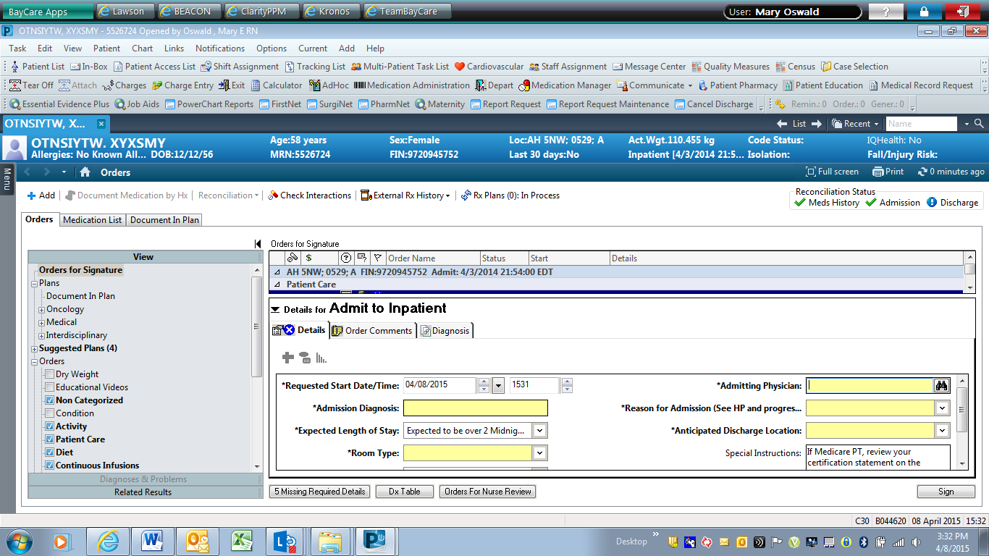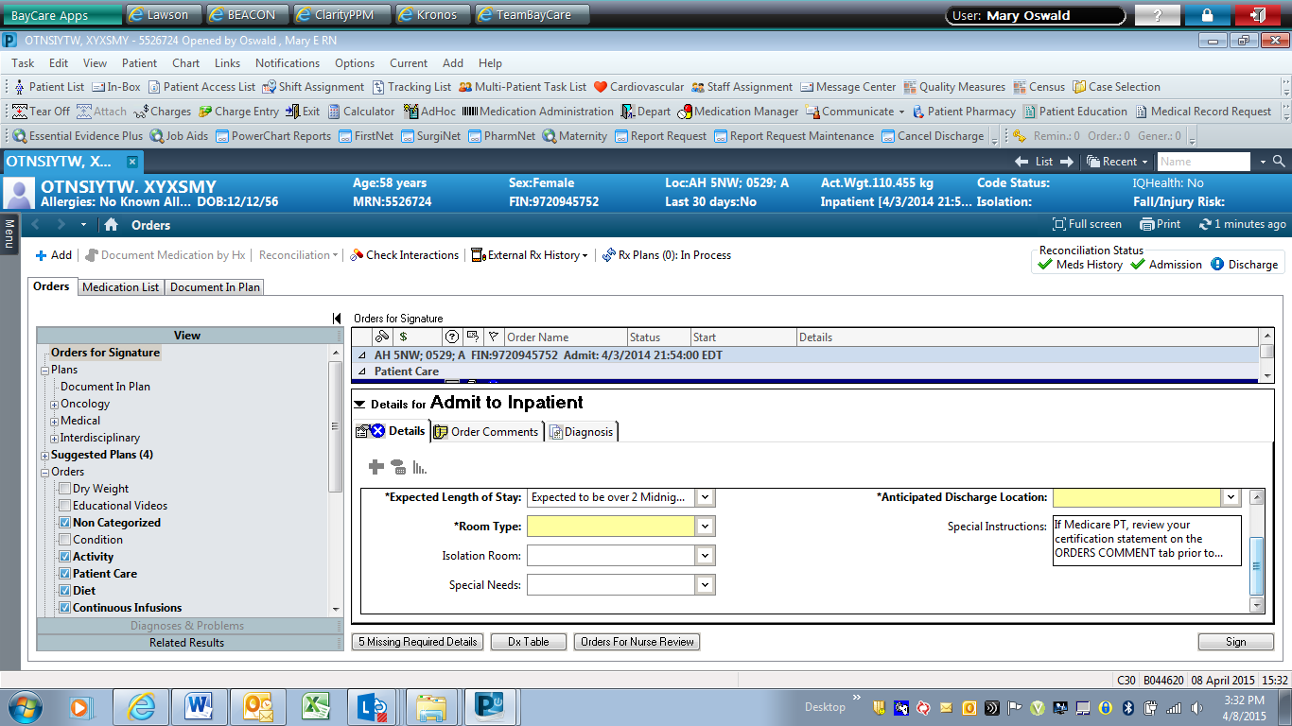

Fields Unique to Admit to Inpatient Order

|  |  |
| --- | --- |
| Field Name | Allowable Codes from Dropdown List |
| Expected Length of Stay | Expected to be over 2 Midnights |
| Expected to be under 2 Midnights |
| Reason for Admission | Intensity of Treatment |
| Severity of Illness |
| Newborn |
| Risk of Adverse Outcomes |
| Risk of Readmission |
| Anticipated Discharge Location | Home with Home Health Care |
| Skilled Facility |
| Home |
| Other |

MSH|^~\&|HNAM|CERNER|SJH|BAYCARE|20150409084144||ORM^O01|Q1915694189T2197353878||2.3||||||8859/1PID|1|2104707746^^^BayCare MRN^MRN^SOARIAN|2104707746^^^BayCare MRN^MRN^SOARIAN~300136085^^^BayCare CMRN^Community Medical Record Number^SOARIAN|300136085^^^BayCare EAD CPI^Historical CMRN^SOARIAN|ASTONMARTIN^ERIC||19870702|M||W|1545 HAPPY BLVD^^Saint Petersburg^FL^33702^^Home~none^^^^^^e-mail||(727)420-6777^PRN||ENG|M|SHI|1100097255^^^BayCare FIN||||HIS|||0PV1|1|E|ERDJH^^^SJH^^Ambulatory(s)^SJH|X|||66666^Unassigned^ER Doctor^^^^^^SJH|||ERD||||EO||N|66666^Unassigned^ER Doctor^^^^^^SJH|E||8|||||||||||||||||||SJH||Active|||20150406095000PV2|||^PARTIED TO HARD|||||||0||||||||||||CONFID|^^589748IN1|1|63593627^108|6249194|Uninsured|||||Uninsured|||20150406120103|21001231000000|||ASTONMARTIN^ERIC^^^^^Current|CD:741726141|19870702|1545 HAPPY BLVD^^Saint Petersburg^FL^33702|||0|||||||||||||||||||||M||||||NONEIN2|0||||||||||||||||||||||||||||||||||||||||||||||||||||||||||||NONE||(727)420-6777ORC|SN|4323622507^HNAM_ORDERID|||20||||20150409084008|B044620^Jmirsw^Zrtg^N^^^^^External Id^Personnel^^^External Identifier||79348^Held^Jeffrey^A^^^^^SJH|||20150409084143|||Written^Written/Paper/Fax|B044620^Jmirsw^Zrtg^N^^^^^External Id^Personnel^^^External IdentifierOBR|1|4323622507^HNAM_ORDERID||Admit To^Admit to Inpatient|||||||||If Medicare PT, review your certification statement on the ORDERS COMMENT tab prior to signing order|||79348^Held^Jeffrey^A^^^^^SJH||||||20150409084143||Admit/Transfer/Discharge|||1^^0^20150409084000^^^If Medicare PT, review your certification statement on the ORDERS COMMENT tab prior to signing orderNTE|1|ORDCOM|If I am admitting a Medicare Patient\.br\\.br\I certify that inpatient services were ordered in accordance with the Medicare regulations governing the order. Based on my medical judgement, hospital inpatient services are reasonable and necessary and in the case of services not specified as inpatient- only under 42 CFR 419.22 (n), that they are appropriately provided as inpatient services in accordance with the 2-midnight benchmark under 42 CFR 412.3 (e).OBX|1|ST|Admission Diagnosis^Admission Diagnosis||mary's testOBX|2|IS|Room Type^Room Type||General Pedi PulmonaryOBX|3|IS|CD:698824468^Expected Length of Stay||CD:698583774OBX|4|IS|CD:698825039^Reason for Admission (See H&P and progre||CD:698600376OBX|5|IS|CD:698825299^Anticipated Discharge Location||CD:698596360

Fields Common to Admit to and Admit Additional Bed Info Orders

| Field Name | Room Type | Isolation Room | Special Needs |
| --- | --- | --- | --- |
| Allowable Codes from Drop Down List | OB Services | Infectious Unspecified | Latex Allergy |
| SJ CDU OSV No Bed Needed | Airborne | Fever > 100.4 |
| General Medical | HIV Immunosuppressed | Freq VS or Neuro Checks |
| General Surgical | HIV Respiratory Presentation | AFB Cultures Ordered |
| General Orthopedics | History of MRSA | Trach |
| General Pedi | History of VRE | Chest Tube |
| General Pedi Pulmonary | Resistant Organism | Intubated / Vent |
| Telemetry Cardiac | RSV | IV Drip Insulin |
| Telemetry Med/Surg | Undiagnosed Diarrhea | IV Drip Titrated Cardiac |
| Telemetry Neuro | Wound Contained w Dressing | IV Drip Titrated Other |
| ICU Adult | Wound Open Draining | Glucostabilizer |
| ICU Pedi |  | Hemodialysis |
| ICU Neonatal |  | Peritoneal Dialysis |
| Behavior Health |  | Pedi Acute Life Threatening Event |
| Oncology Adult |  | Pedi Apnea Monitor |
| Oncology Pedi |  | Pedi Crib Covered |
| Private Room MD or Pt Preference |  | Pedi Crib Uncovered |
| Private Room Medically Needed |  | Confidential Pt / No Info |
| Private Room DNR |  | Baker Act |
| Private Room VIP or Courtesy |  | Behavior Issue |
| Progressive Care Unit |  | Leather Restraints |
| Well Newborn |  | Prisoner |
|  |  | Elopement Risk |
|  |  | Sitter |
|  |  | Place Near Nursing Station |
|  |  | Confused / Quiet |
|  |  | Confused / Loud |
|  |  | Camera Observation |
|  |  | Orthopedic Traction |
|  |  | Obesity > 350 lbs. |
|  |  | Seizure LTM |

* 1. Place in Observation (Patient Class E)

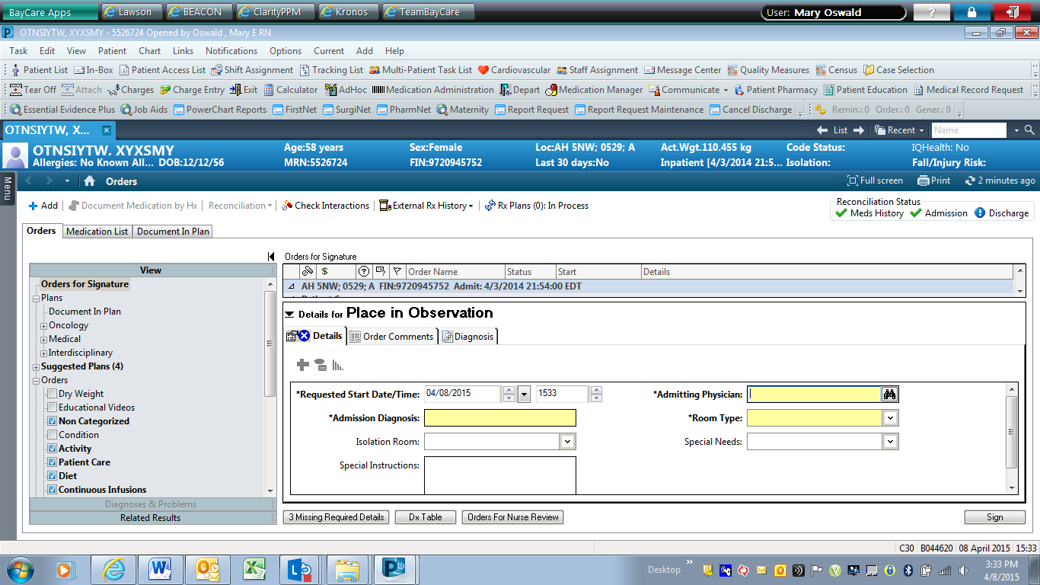

MSH|^~\&|HNAM|CERNER|SJH|BAYCARE|20150409084144||ORM^O01|Q1915694188T2197353877||2.3||||||8859/1PID|1|2104707746^^^BayCare MRN^MRN^SOARIAN|2104707746^^^BayCare MRN^MRN^SOARIAN~300136085^^^BayCare CMRN^Community Medical Record Number^SOARIAN|300136085^^^BayCare EAD CPI^Historical CMRN^SOARIAN|ASTONMARTIN^ERIC||19870702|M||W|1545 HAPPY BLVD^^Saint Petersburg^FL^33702^^Home~none^^^^^^e-mail||(727)420-6777^PRN||ENG|M|SHI|1100097255^^^BayCare FIN||||HIS|||0PV1|1|E|ERDJH^^^SJH^^Ambulatory(s)^SJH|X|||66666^Unassigned^ER Doctor^^^^^^SJH|||ERD||||EO||N|66666^Unassigned^ER Doctor^^^^^^SJH|E||8|||||||||||||||||||SJH||Active|||20150406095000PV2|||^PARTIED TO HARD|||||||0||||||||||||CONFID|^^589748IN1|1|63593627^108|6249194|Uninsured|||||Uninsured|||20150406120103|21001231000000|||ASTONMARTIN^ERIC^^^^^Current|CD:741726141|19870702|1545 HAPPY BLVD^^Saint Petersburg^FL^33702|||0|||||||||||||||||||||M||||||NONEIN2|0||||||||||||||||||||||||||||||||||||||||||||||||||||||||||||NONE||(727)420-6777ORC|SN|4323622283^HNAM_ORDERID|||20||||20150409084008|B044620^Jmirsw^Zrtg^N^^^^^External Id^Personnel^^^External Identifier||79348^Held^Jeffrey^A^^^^^SJH|||20150409084143|||Written^Written/Paper/Fax|B044620^Jmirsw^Zrtg^N^^^^^External Id^Personnel^^^External IdentifierOBR|1|4323622283^HNAM_ORDERID||Admit To^Place in Observation||||||||||||79348^Held^Jeffrey^A^^^^^SJH||||||20150409084143||Admit/Transfer/Discharge|||1^^0^20150409084000OBX|1|IS|Special Needs for Bed Request^Special Needs for Bed Request||Chest TubeOBX|2|ST|Admission Diagnosis^Admission Diagnosis||mary's testOBX|3|IS|Room Type^Room Type||Telemetry Med/SurgOBX|4|IS|Isolation Room^Isolation Room||Airborne

1. Admit Additional Bed Info (Patient Class E)

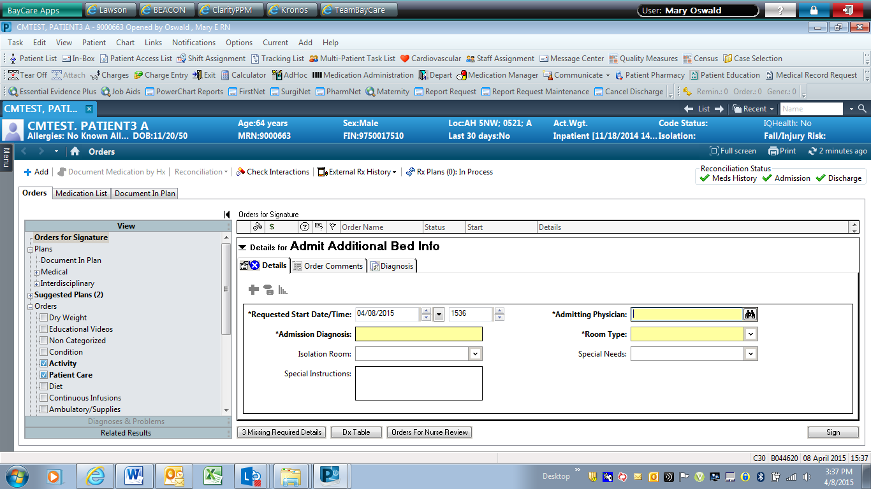

MSH|^~\&|HNAM|CERNER|SJH|BAYCARE|20150409084144||ORM^O01|Q1915694190T2197353879||2.3||||||8859/1PID|1|2104707746^^^BayCare MRN^MRN^SOARIAN|2104707746^^^BayCare MRN^MRN^SOARIAN~300136085^^^BayCare CMRN^Community Medical Record Number^SOARIAN|300136085^^^BayCare EAD CPI^Historical CMRN^SOARIAN|ASTONMARTIN^ERIC||19870702|M||W|1545 HAPPY BLVD^^Saint Petersburg^FL^33702^^Home~none^^^^^^e-mail||(727)420-6777^PRN||ENG|M|SHI|1100097255^^^BayCare FIN||||HIS|||0PV1|1|E|ERDJH^^^SJH^^Ambulatory(s)^SJH|X|||66666^Unassigned^ER Doctor^^^^^^SJH|||ERD||||EO||N|66666^Unassigned^ER Doctor^^^^^^SJH|E||8|||||||||||||||||||SJH||Active|||20150406095000PV2|||^PARTIED TO HARD|||||||0||||||||||||CONFID|^^589748IN1|1|63593627^108|6249194|Uninsured|||||Uninsured|||20150406120103|21001231000000|||ASTONMARTIN^ERIC^^^^^Current|CD:741726141|19870702|1545 HAPPY BLVD^^Saint Petersburg^FL^33702|||0|||||||||||||||||||||M||||||NONEIN2|0||||||||||||||||||||||||||||||||||||||||||||||||||||||||||||NONE||(727)420-6777ORC|SN|4323622611^HNAM_ORDERID|||20||||20150409084008|B044620^Jmirsw^Zrtg^N^^^^^External Id^Personnel^^^External Identifier||79348^Held^Jeffrey^A^^^^^SJH|||20150409084143|||Written^Written/Paper/Fax|B044620^Jmirsw^Zrtg^N^^^^^External Id^Personnel^^^External IdentifierOBR|1|4323622611^HNAM_ORDERID||ADMIT BED INFO^Admit Additional Bed Info||||||||||||79348^Held^Jeffrey^A^^^^^SJH||||||20150409084143||Admit/Transfer/Discharge|||1^^0^20150409084000OBX|1|IS|Special Needs for Bed Request^Special Needs for Bed Request||Confidential Pt / No InfoOBX|2|ST|Admission Diagnosis^Admission Diagnosis||mary's testOBX|3|IS|Room Type^Room Type||Progressive Care UnitOBX|4|IS|Isolation Room^Isolation Room||Infectious Unspecified

1. Discharge Patient (Patient Class I): This order has no code sets (pick lists). 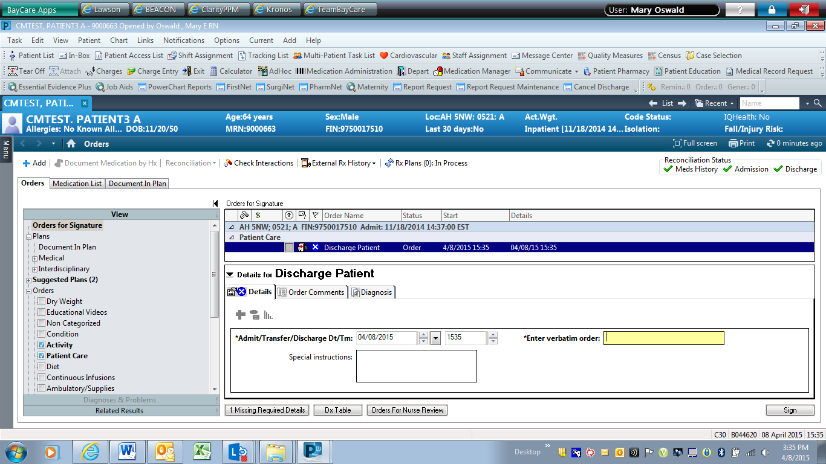

Fields Unique to Discharge Patient Order

|  |  |
| --- | --- |
| Field Name | Allowable Values |
| Admit/Transfer/Discharge Dt/Tm | Populates OBR 27.4? |
| Enter verbatim order | The person ordering must fill in the field ENTER VERBATIM ORDER prior to signing the order; populates OBX segment |

MSH|^~\&|HNAM|CERNER|SJH|BAYCARE|20150409083427||ORM^O01|Q1915693900T2197353301||2.3||||||8859/1PID|1|852369^^^SJH^MRN|852369^^^SJH^MRN||Cup^Butter||20000101|M||||||||||4000000435227^^^SJH FIN|||||||0PV1|1|I|2E^B203^A^SJH^^Bed(s)^SJH|||||||||||||||I|||||||||||||||||||||SJH||Active|||20150205104100PV2||||||||||0||||||||||||CONFID|^^589748ORC|SN|4323613721^HNAM_ORDERID|||20||||20150409083213|B044620^Jmirsw^Zrtg^N^^^^^External Id^Personnel^^^External Identifier||79348^Held^Jeffrey^A^^^^^SJH|||20150409083426|||Written^Written/Paper/Fax|B044620^Jmirsw^Zrtg^N^^^^^External Id^Personnel^^^External IdentifierOBR|1|4323613721^HNAM_ORDERID||Discharge Patient^Discharge Patient||||||||||||79348^Held^Jeffrey^A^^^^^SJH||||||20150409083426||Admit/Transfer/Discharge|||1^^0^20150409083200OBX|1|ST|Freetext Orderable^Freetext Orderable||send home

1. Isolation (Patient Class I)

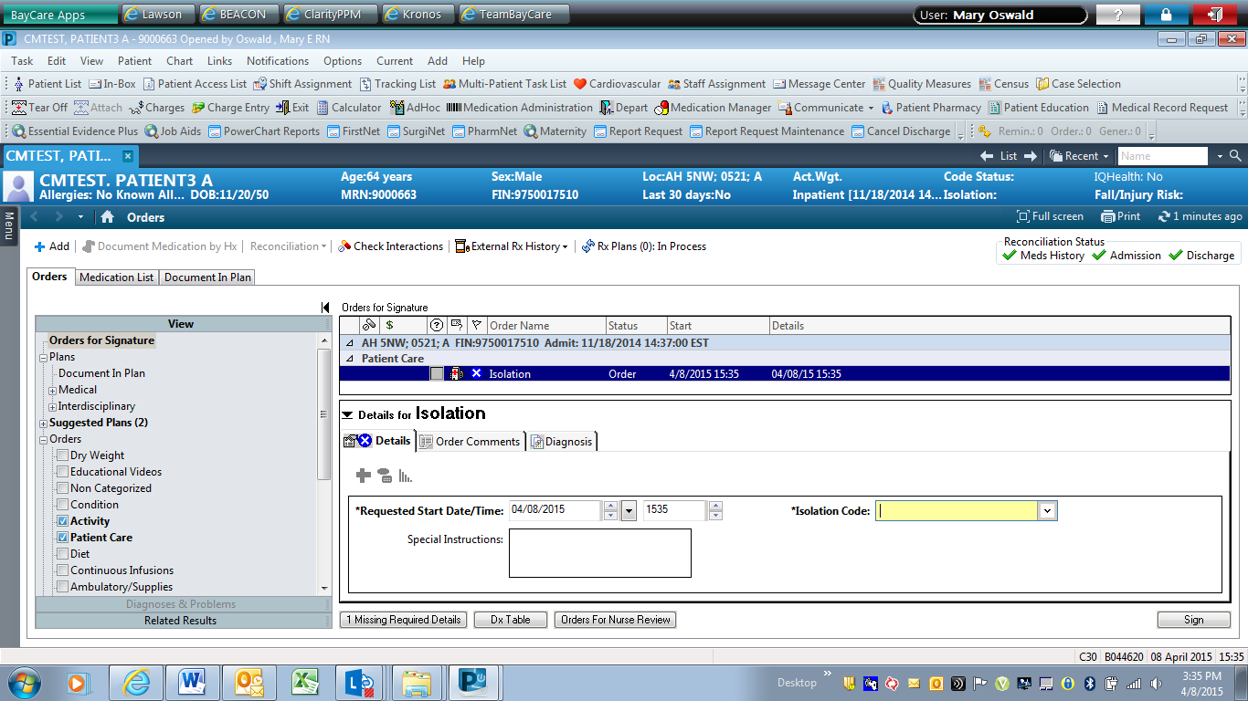

Fields Unique to Isolation Order

|  |  |  |
| --- | --- | --- |
| Field Name | Allowable Codes | Display |
| Requested Start Date/Time | Populates OBR 27.4 |  |
| Isolation Code | A Airborne | Airborne |
| C Contact | Contact |
| D Droplet | Droplet |
| B Airborne Contact | Airborne and Contact |
| H High Risk | High Risk |
| C Contact (Bleach) | Contact (Bleach) |
| E Contact/Droplet | Contact and Droplet |
| D Special Droplet (H1N1) | Special Droplet |
| No Isolation Required | No Isolation Required |

MSH|^~\&|HNAM|CERNER|SJH|BAYCARE|20150409083427||ORM^O01|Q1915693901T2197353303||2.3||||||8859/1PID|1|852369^^^SJH^MRN|852369^^^SJH^MRN||Cup^Butter||20000101|M||||||||||4000000435227^^^SJH FIN|||||||0PV1|1|I|2E^B203^A^SJH^^Bed(s)^SJH|||||||||||||||I|||||||||||||||||||||SJH||Active|||20150205104100PV2||||||||||0||||||||||||CONFID|^^589748ORC|SN|4323613863^HNAM_ORDERID|||20||||20150409083213|B044620^Jmirsw^Zrtg^N^^^^^External Id^Personnel^^^External Identifier||79348^Held^Jeffrey^A^^^^^SJH|||20150409083426|||Written^Written/Paper/Fax|B044620^Jmirsw^Zrtg^N^^^^^External Id^Personnel^^^External IdentifierOBR|1|4323613863^HNAM_ORDERID||Isolation^Isolation||||||||C Contact^Contact||||79348^Held^Jeffrey^A^^^^^SJH||||||20150409083426||Patient Care|||1^^0^20150409083200

1. Anticipated Date of Discharge (ADOD) (Patient Class I)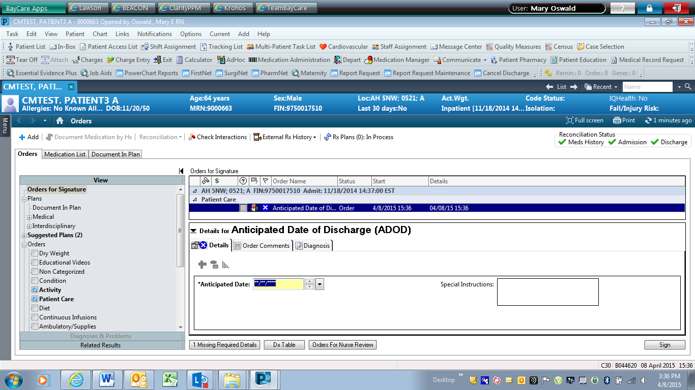

Fields Unique to Anticipated Date of Discharge (ADOD) Order

|  |  |
| --- | --- |
| Field Name | Allowable Values |
| Anticipated Date | The person entering the order must enter the Anticipated Date prior to signing the order; populates the OBX segment |

MSH|^~\&|HNAM|CERNER|SJH|BAYCARE|20150409083428||ORM^O01|Q1915693903T2197353304||2.3||||||8859/1PID|1|852369^^^SJH^MRN|852369^^^SJH^MRN||Cup^Butter||20000101|M||||||||||4000000435227^^^SJH FIN|||||||0PV1|1|I|2E^B203^A^SJH^^Bed(s)^SJH|||||||||||||||I|||||||||||||||||||||SJH||Active|||20150205104100PV2||||||||||0||||||||||||CONFID|^^589748ORC|SN|4323614039^HNAM_ORDERID|||20||||20150409083213|B044620^Jmirsw^Zrtg^N^^^^^External Id^Personnel^^^External Identifier||79348^Held^Jeffrey^A^^^^^SJH|||20150409083426|||Written^Written/Paper/Fax|B044620^Jmirsw^Zrtg^N^^^^^External Id^Personnel^^^External IdentifierOBR|1|4323614039^HNAM_ORDERID||ADOD^Anticipated Date of Discharge||||||||||||79348^Held^Jeffrey^A^^^^^SJH||||||20150409083426||Communication Orders|||1^^0^20150409083200OBX|1|DT|Anticipated Date^Anticipated Date||20150410

# **5. Testing**

## 5.1. Unit Testing Scenarios

|  |  |
| --- | --- |
| **Scenario** | **Expected Result** |
|  |  |
|  |  |
|  |  |
|  |  |
|  |  |

## 5.2 Integrated Testing Scenarios

|  |  |
| --- | --- |
| **Scenario** | **Expected Result** |
|  |  |
|  |  |
|  |  |
|  |  |
|  |  |
|  |  |

## 5.3 Testing Approvals

|  |  |  |  |
| --- | --- | --- | --- |
| **Testing Phase** | **Date** | **Department** | **Team Member** |
| PH1.UNIT |  |  |  |
| PH1.INTEGRATED |  |  |  |

### 

## 5.4 Piloting

List the facilities and associated networks in scope for pilot testing.

## 5.5 Approvals

|  |  |  |  |
| --- | --- | --- | --- |
| **Testing Phase** | **Date** | **Department** | **Team Member** |
| PH1.0 |  |  |  |
|  |  |  |  |
|  |  |  |  |

# 6. Deployment / Implementation Model

Provide the detail as to how to deploy the solution defined in the IDBB from both the BAYCARE and vendor perspective.

## 6.1 Alerts

Are you going to need alerting on this connection?

|  |  |
| --- | --- |
| Yes | ☐ **yes** |
| No | ☐ |

If the answer is yes, please complete the table below:

|  |  |  |  |
| --- | --- | --- | --- |
| **Site Name** | **Hours of Support** | **Distribution Group** | **Comments** |
|  |  |  |  |
| teletrac_24_p | 24x7 | IS Ancillary Applications Team |  |

# Appendix A: Risks and Concerns

|  |  |  |  |  |  |  |  |  |
| --- | --- | --- | --- | --- | --- | --- | --- | --- |
| **Project Name** |  |  | | |  |  |  |  |
| **Number** | **Risk / Concern** | **Comment** | **Mitigation** | | |  |  |  |
| RC.2013.1.0 |  |  | |  | |  |  |  |

# Appendix B: Issues List

This is a dynamic list of the open issues related to the IDBB that remain to be solved, including but not limited to TBDs, pending decisions, information needed, conflict awaiting resolution, and the like.

|  |  |  |  |  |  |  |  |  |
| --- | --- | --- | --- | --- | --- | --- | --- | --- |
| **Project Name** |  |  | | |  |  |  |  |
| **Number** | **Issue** | **Comment** | **Fix** | | |  |  |  |
| I.2013.1.0 |  |  | |  | |  |  |  |

* End of document